Отчет по ЛР 2

Выполнил Логвинов Андрей, ИВТ, 2 гр, 3 п гр

**Изображение диаграммы**

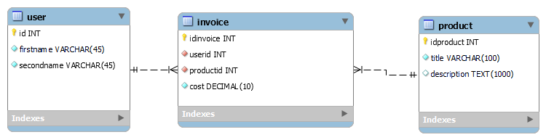

**SQL Запрос**

-- MySQL Script generated by MySQL Workbench

-- Thu Feb 24 09:46:49 2022

-- Model: New Model Version: 1.0

-- MySQL Workbench Forward Engineering

SET @OLD_UNIQUE_CHECKS=@@UNIQUE_CHECKS, UNIQUE_CHECKS=0;

SET @OLD_FOREIGN_KEY_CHECKS=@@FOREIGN_KEY_CHECKS, FOREIGN_KEY_CHECKS=0;

SET @OLD_SQL_MODE=@@SQL_MODE, SQL_MODE='ONLY_FULL_GROUP_BY,STRICT_TRANS_TABLES,NO_ZERO_IN_DATE,NO_ZERO_DATE,ERROR_FOR_DIVISION_BY_ZERO,NO_ENGINE_SUBSTITUTION';

-- -----------------------------------------------------

-- Schema firstModel

-- -----------------------------------------------------

-- -----------------------------------------------------

-- Schema firstModel

-- -----------------------------------------------------

CREATE SCHEMA IF NOT EXISTS `firstModel` DEFAULT CHARACTER SET utf8 ;

USE `firstModel` ;

-- -----------------------------------------------------

-- Table `firstModel`.`user`

-- -----------------------------------------------------

CREATE TABLE IF NOT EXISTS `firstModel`.`user` (

`id` INT NOT NULL AUTO_INCREMENT,

`firstname` VARCHAR(45) NOT NULL,

`secondname` VARCHAR(45) NOT NULL,

PRIMARY KEY (`id`))

ENGINE = InnoDB;

-- -----------------------------------------------------

-- Table `firstModel`.`product`

-- -----------------------------------------------------

CREATE TABLE IF NOT EXISTS `firstModel`.`product` (

`idproduct` INT NOT NULL AUTO_INCREMENT,

`title` VARCHAR(100) NOT NULL,

`description` TEXT(1000) NULL,

PRIMARY KEY (`idproduct`))

ENGINE = InnoDB;

-- -----------------------------------------------------

-- Table `firstModel`.`invoice`

-- -----------------------------------------------------

CREATE TABLE IF NOT EXISTS `firstModel`.`invoice` (

`idinvoice` INT NOT NULL AUTO_INCREMENT,

`userid` INT NOT NULL,

`productid` INT NOT NULL,

`cost` DECIMAL(10) NOT NULL,

PRIMARY KEY (`idinvoice`),

INDEX `user_idx` (`userid` ASC) VISIBLE,

INDEX `prod_idx` (`productid` ASC) VISIBLE,

CONSTRAINT `user`

FOREIGN KEY (`userid`)

REFERENCES `firstModel`.`user` (`id`)

ON DELETE CASCADE

ON UPDATE CASCADE,

CONSTRAINT `prod`

FOREIGN KEY (`productid`)

REFERENCES `firstModel`.`product` (`idproduct`)

ON DELETE CASCADE

ON UPDATE CASCADE)

ENGINE = InnoDB;

SET SQL_MODE=@OLD_SQL_MODE;

SET FOREIGN_KEY_CHECKS=@OLD_FOREIGN_KEY_CHECKS;

SET UNIQUE_CHECKS=@OLD_UNIQUE_CHECKS;

**Pastebin**

<https://pastebin.com/JZY13f2Y>

**Задание 2**

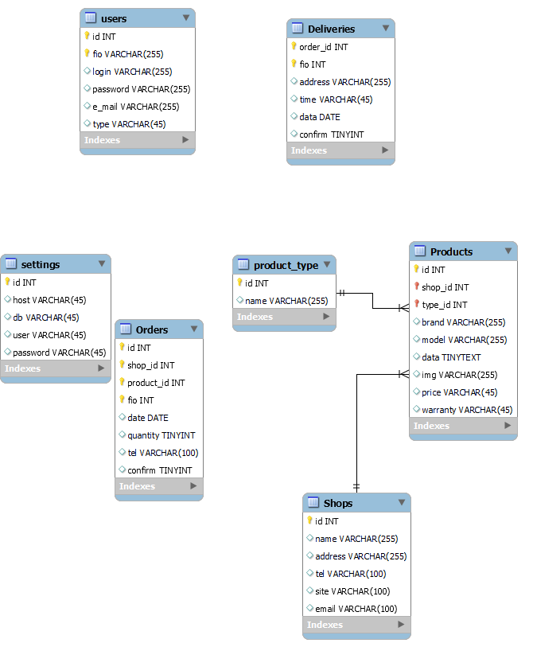

**Создание Orders**

CREATE TABLE IF NOT EXISTS `internet_sales`.`Orders` (

`id` INT NOT NULL,

`shop_id` INT NOT NULL,

`product_id` INT NOT NULL,

`fio` INT NOT NULL,

`date` DATE NULL,

`quantity` TINYINT NULL,

`tel` VARCHAR(100) NULL,

`confirm` TINYINT NULL,

PRIMARY KEY (`id`, `shop_id`, `product_id`, `fio`))

ENGINE = InnoDB

**Pastebin**

<https://pastebin.com/TQCDBxuX>

**Задание 3**

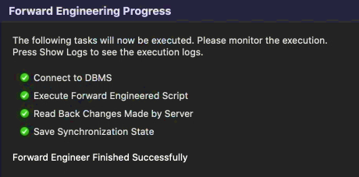

**Pastebin**

ENGINE = InnoDB

**Задание 4**

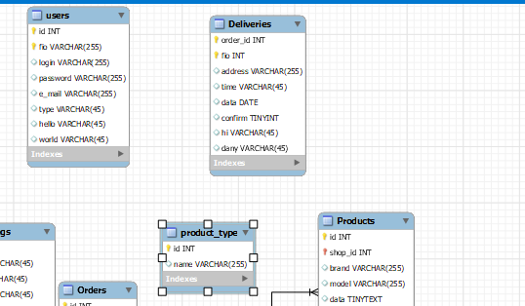

Удалил связанные данные, пропала связь. Т.е. идет автоматическое открепление.

Данные добавляются удобно. Добавлены поля

Hello

World

Hi

Dany

В различные таблицы